Source: CDE, CDD-801A monthly child care report.
Note: Data is point-in-time (October), and does not represent annual aggregates.
Voucher programs include: Alternative Payment, CalWorks Stage 1 and 2, Migrant Alternative Payment
FCC=family child care home, CCC=child care center, LE=license-exempt provider
Vouchers by setting  This chart shows the total number of vouchers used in each child care setting. The slope of each line are:  FCC = 552  CCC = 108  LE = -4,549  This can be interpreted as the average change in voucher use per year. | Voucher utilization by setting  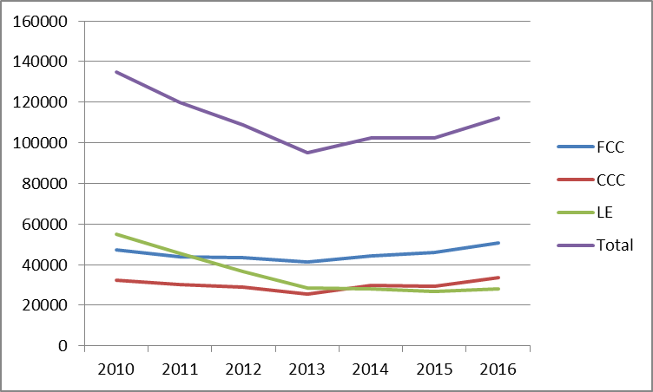
Percentage by setting  This chart shows the proportion of total vouchers that go to each child care setting. The slope of the lines are:  FCC = 1.8%  CCC = 1%  LE = -2.7%  This can be interpreted as the average change in percentage of vouchers going to each setting per year. | Percentage of vouchers used in each setting  